**Nginx**



1. Search and click on EC2

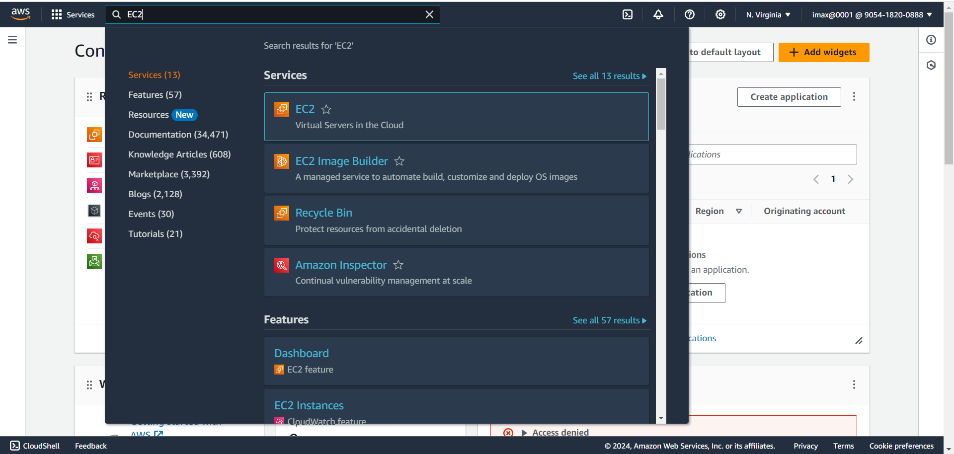

1. Click on Launch instance

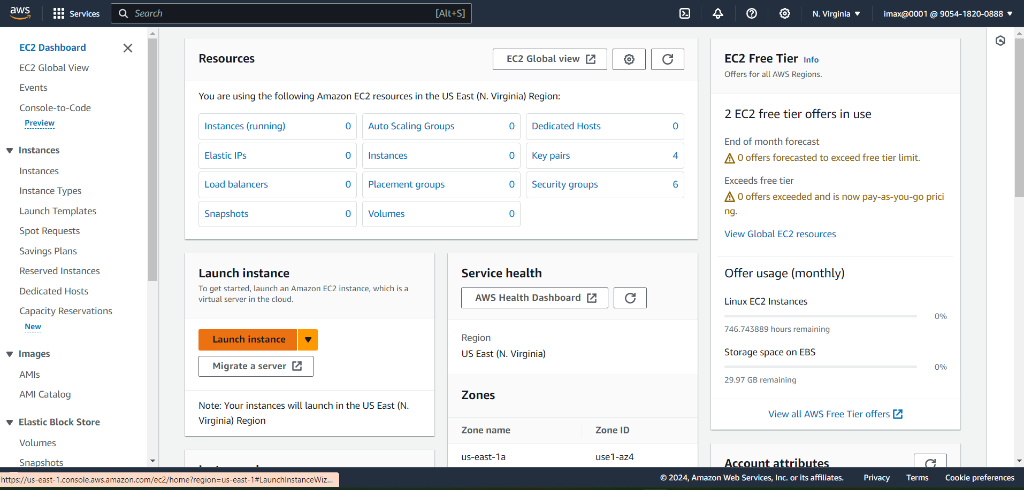

1. Select Ubuntu as Amazon Machin Image(Free tier eligible)

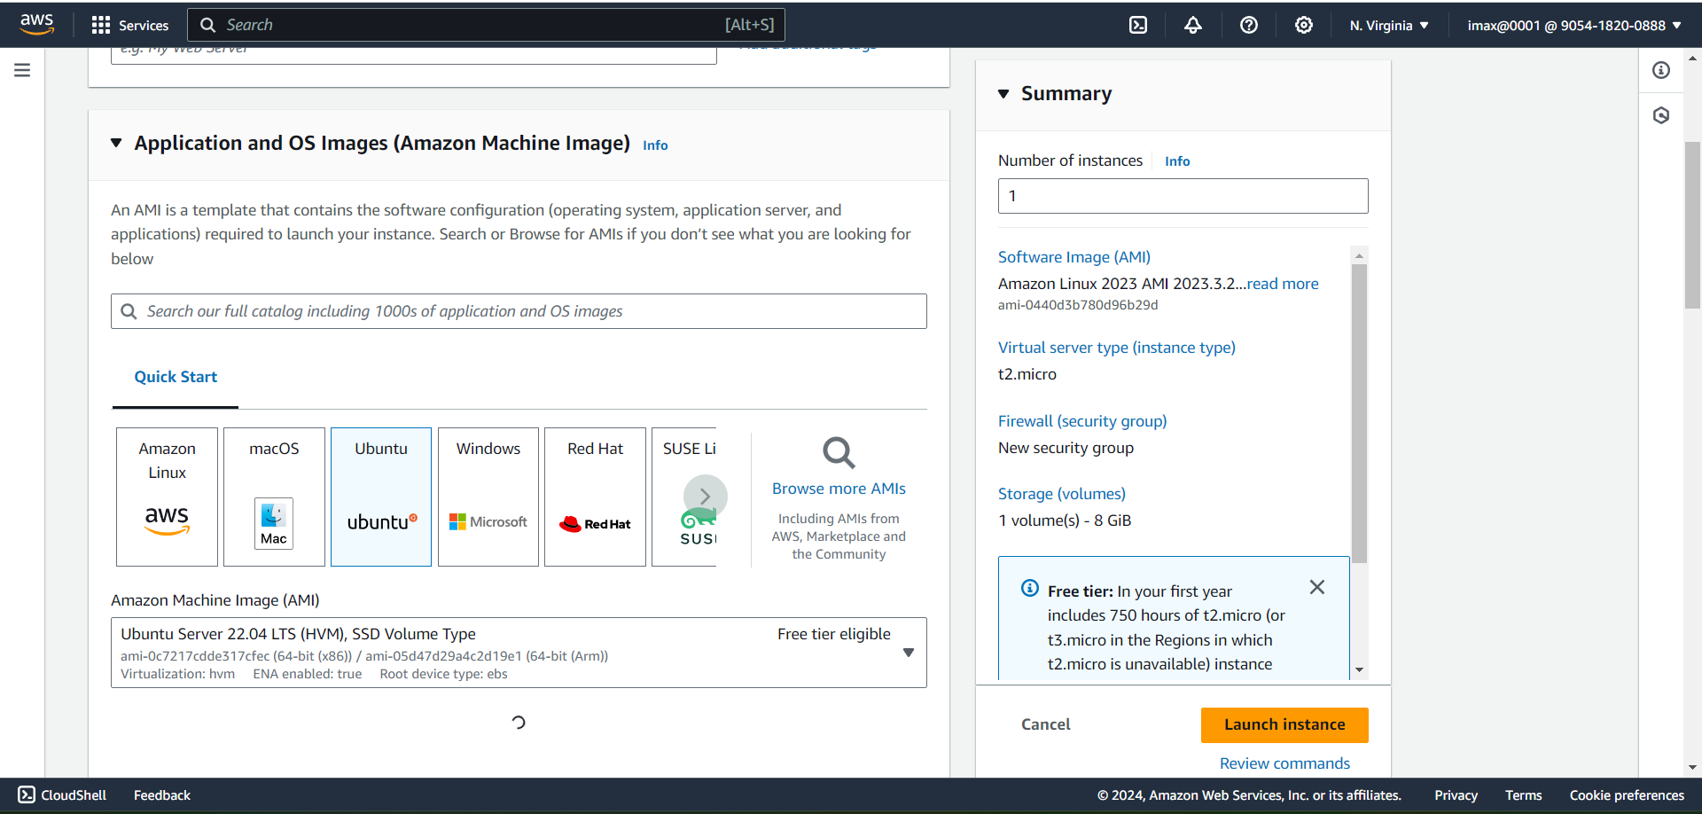

1. Select Instance type(t2.micro) and key pair in drop menu

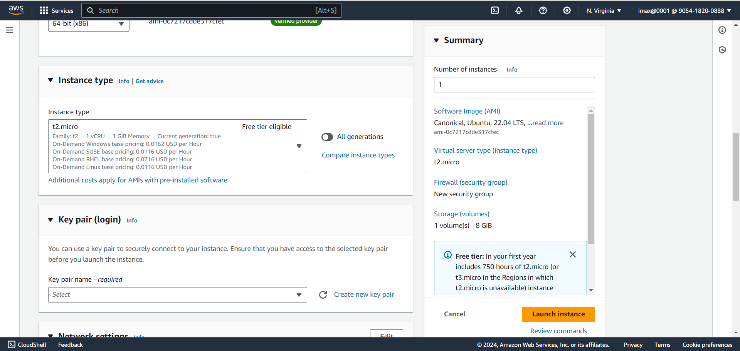

1. In Network section in security group select HTTPS and HTTP and SSH checkbox

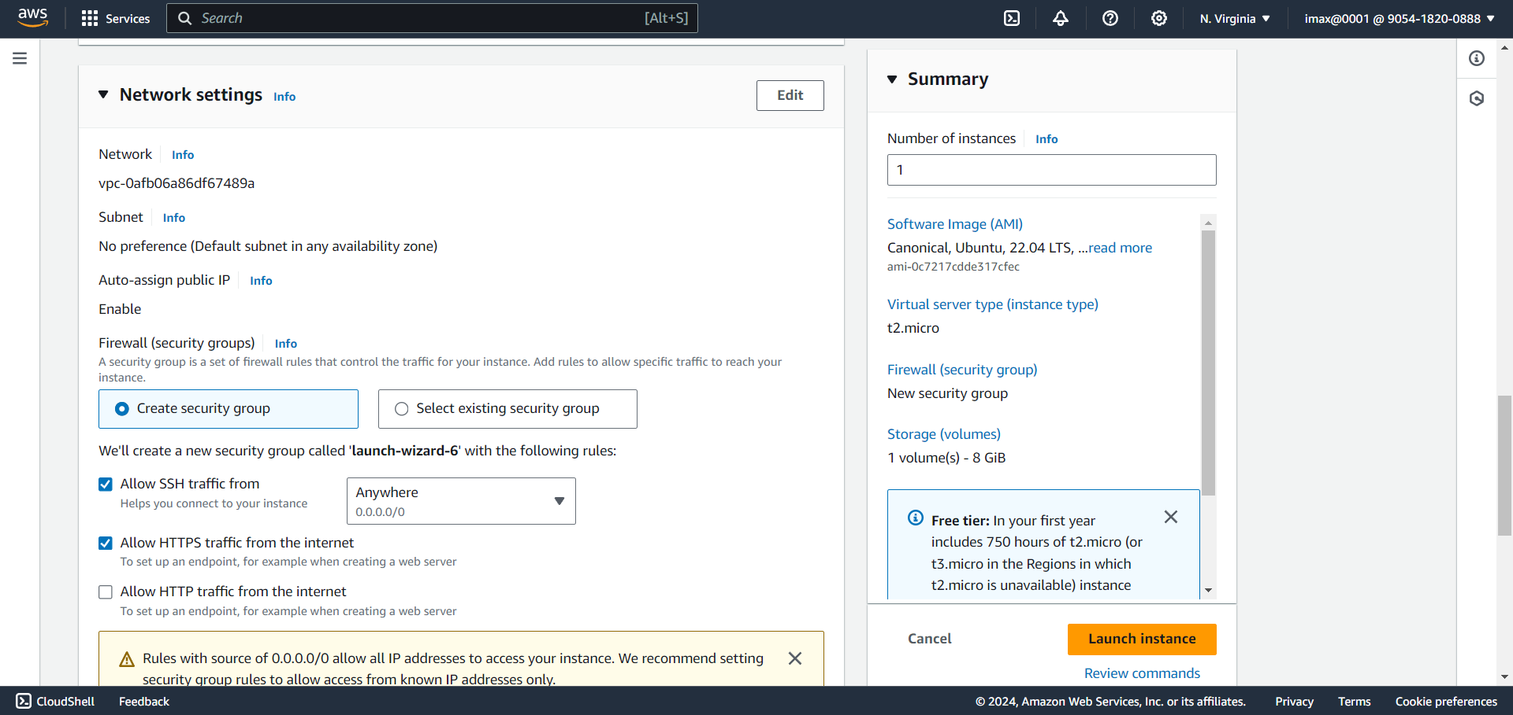

1. In Configure Storage not doing anything just click on ‘Launch instance’.

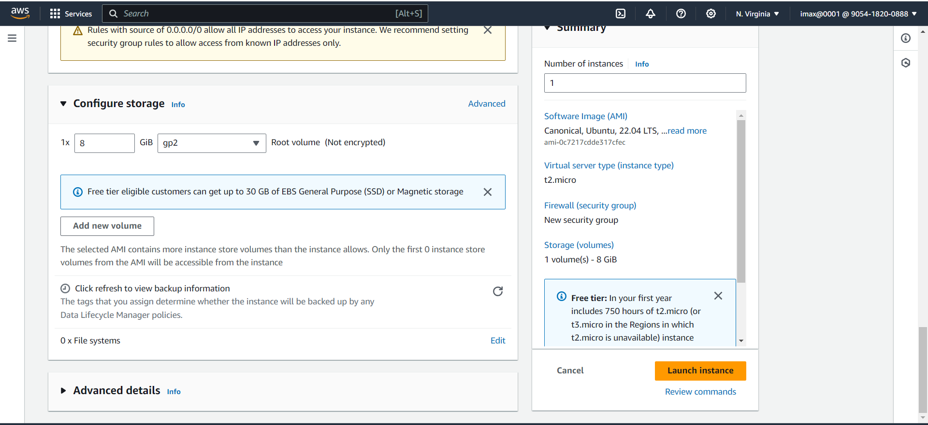

1. Machine launch successfully

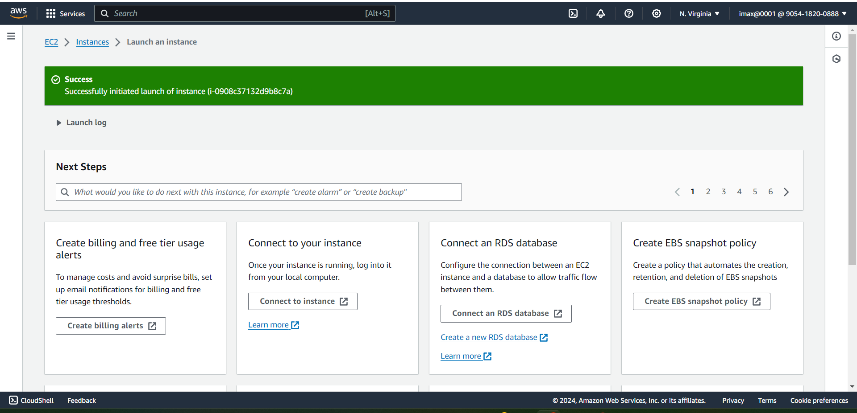

1. Click on View all Instances

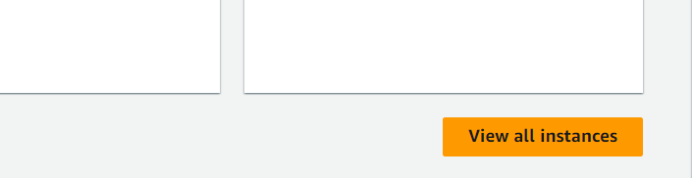

1. Copy that public Ip and hit on web browser

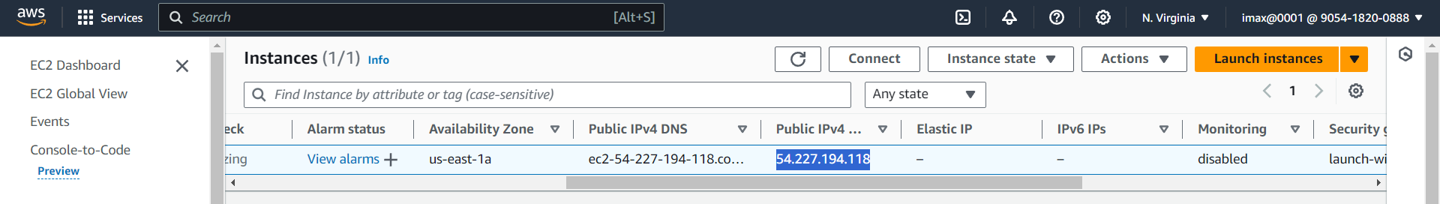

1. After hit public Ip in Web Browser the page display like this because the web server is not configure yet

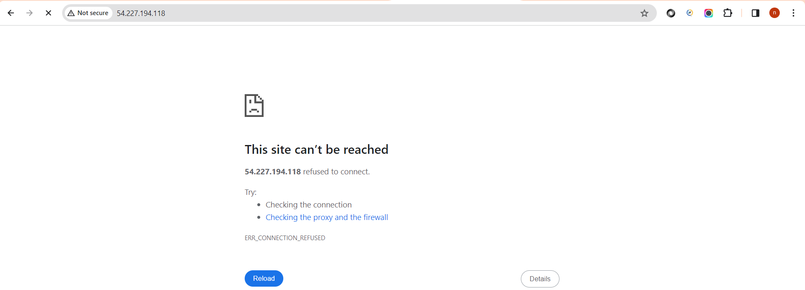

1. Right click on that instance and click on connect

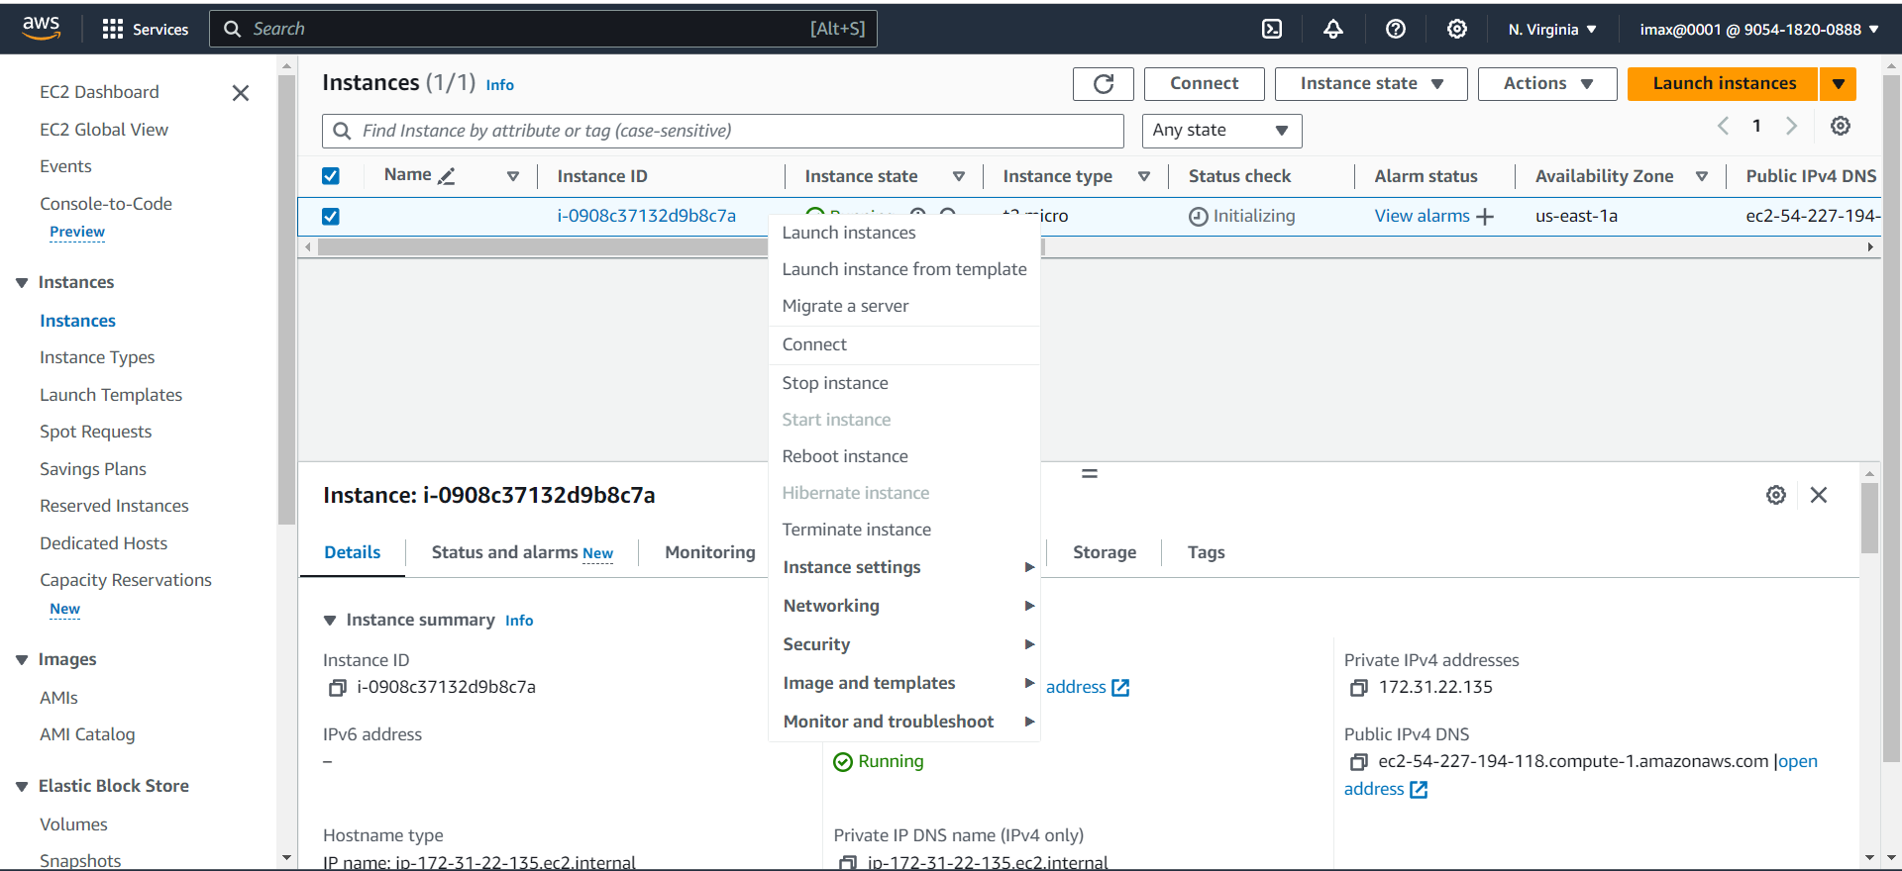

1. Click on Connect

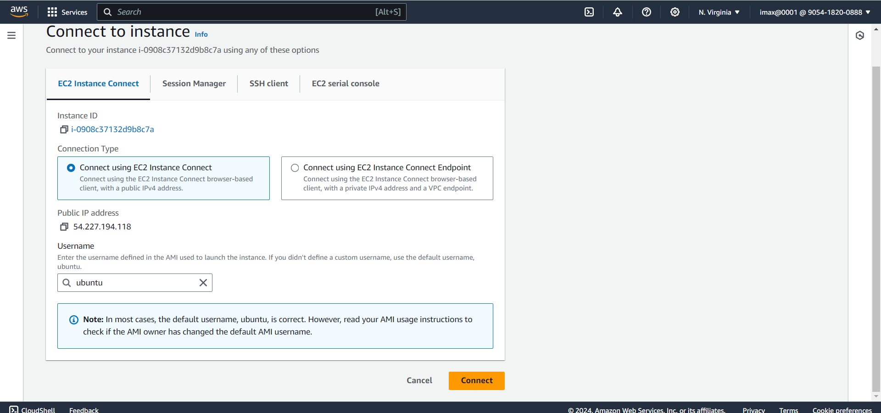

1. After click on Connect the terminal will open

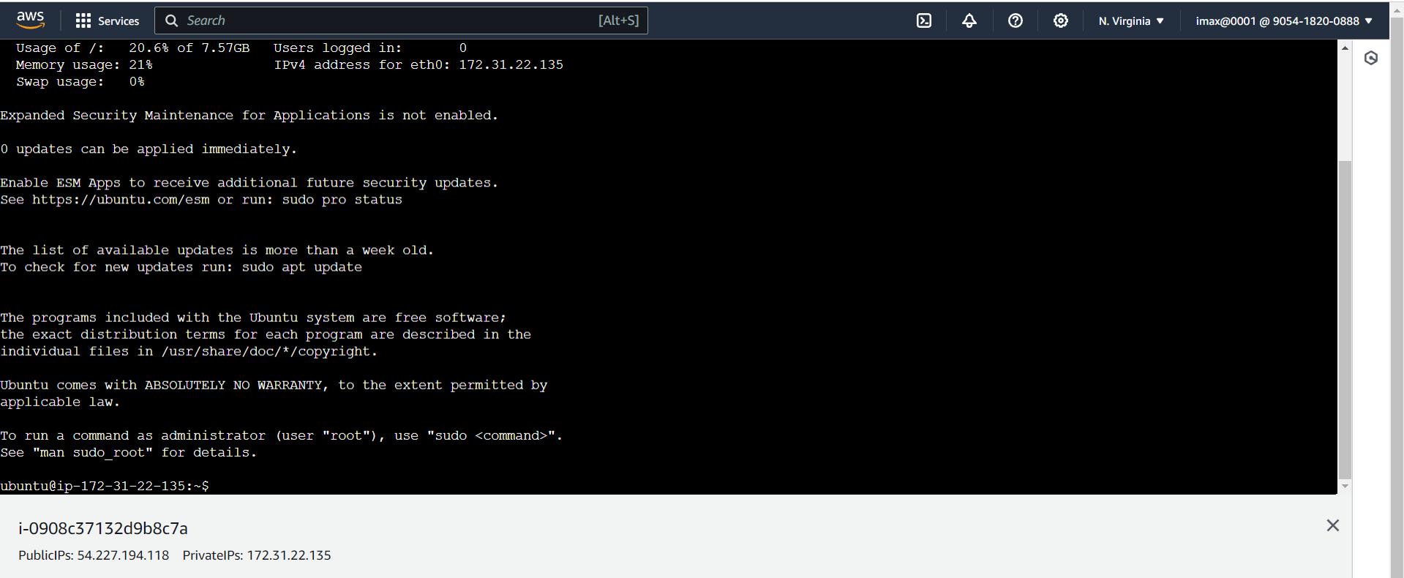

1. To ensure that the latest update and patches are installed by typing ‘sudo apt-get update’

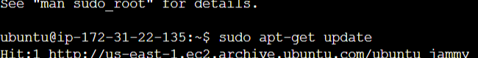

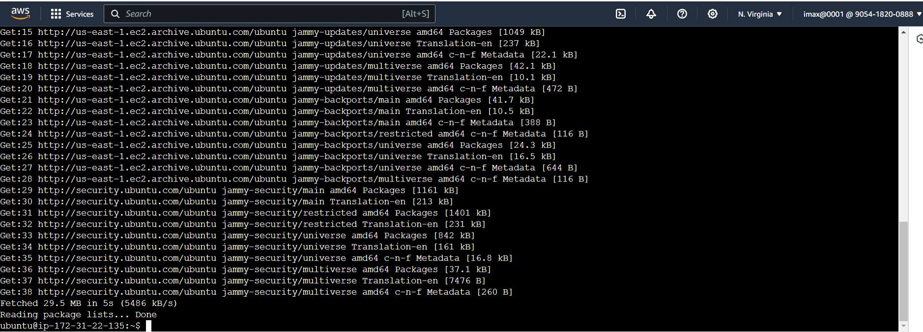

1. Installing Nginx from ubuntu repositories by typing ‘sudo apt-get install nginx’

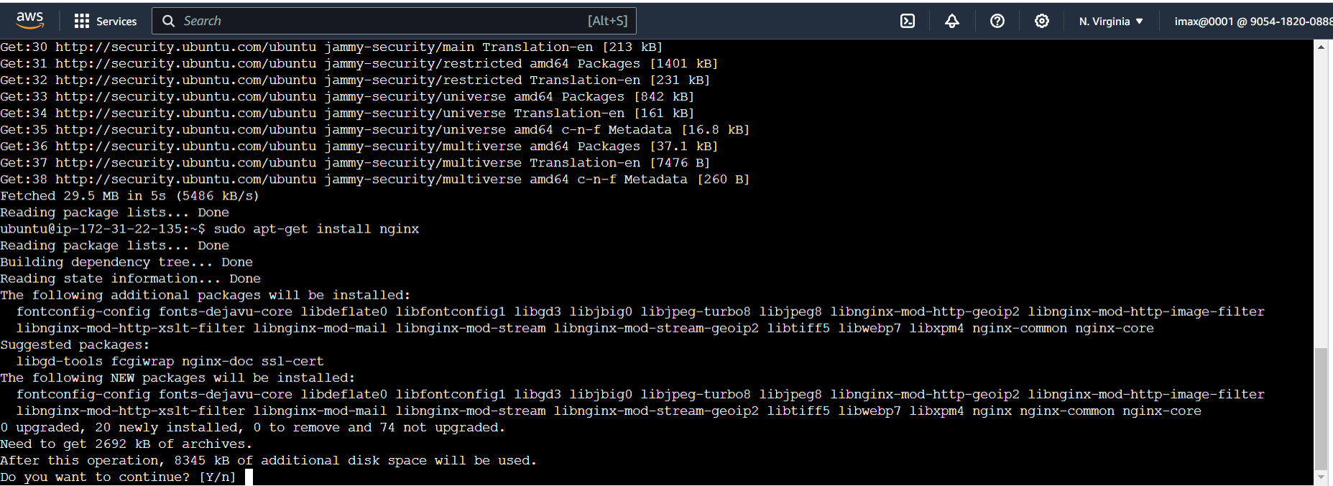

1. To check the version of nginx by typing ‘nginx -v’

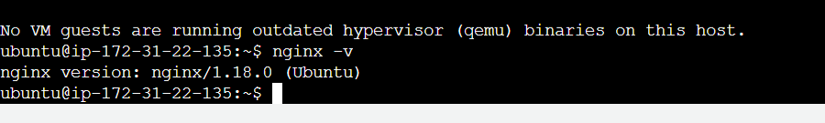

1. Check the status of the nginx by typing ‘sudo systemctl status nginx’

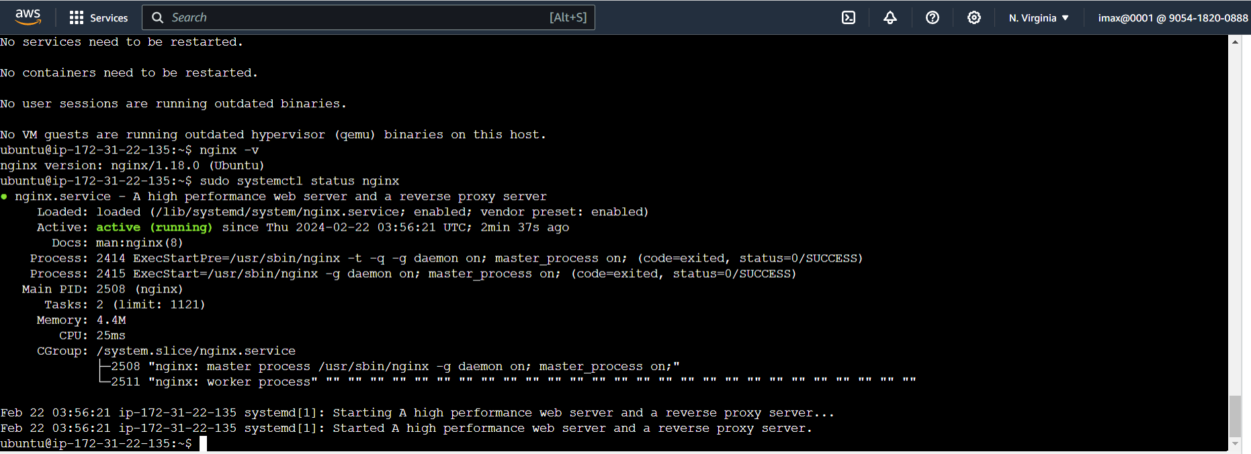

Its active and Running

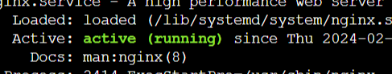

1. Go to web Browser hit Public Ip of that particular instance(we can see that Welcome to nginx!) that means nginx is running our AWS instance

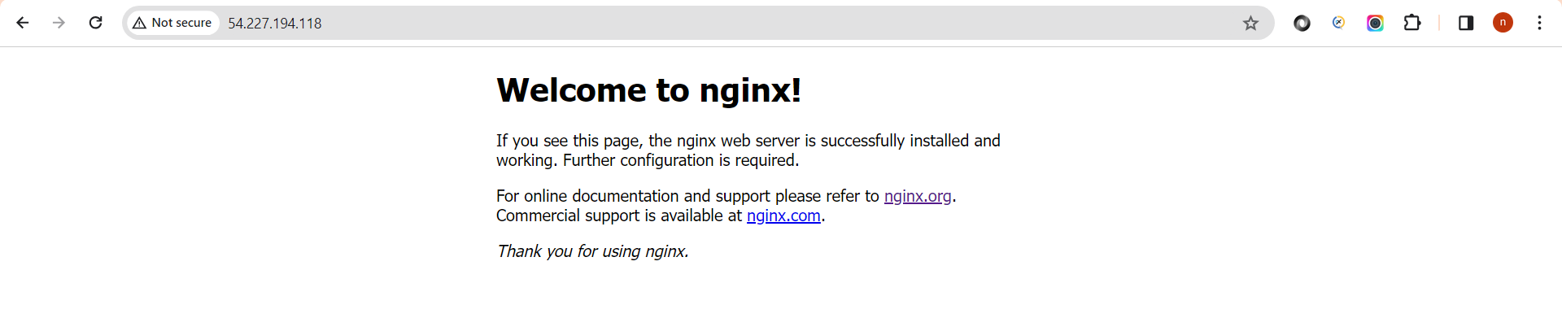

1. Then again go to our Instance page and see our public Ip(Now Public Ip is “54.227.194.118”)

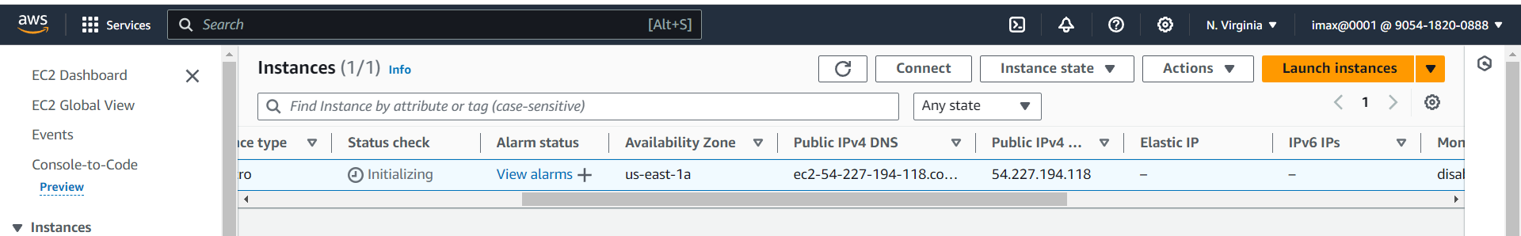

1. Stop the Instance for 1 min for selecting ‘Stop Instance’

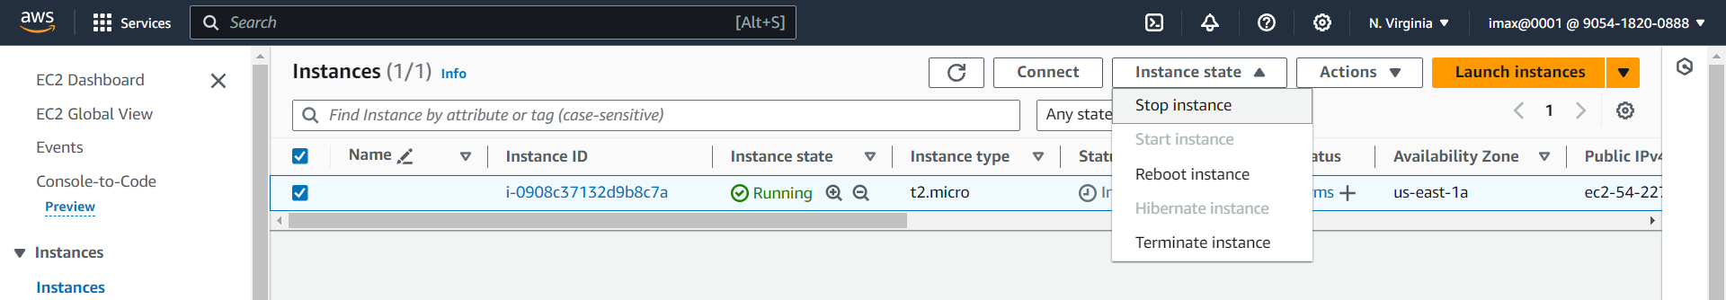

Click on stop

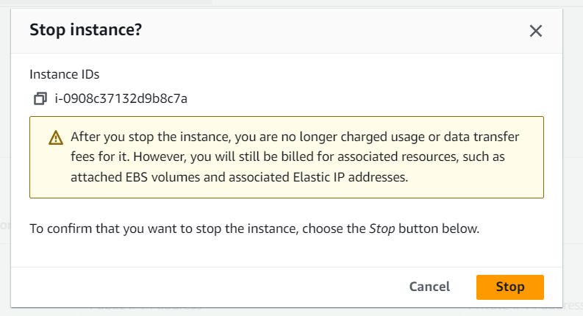

1. After 1 min start the Instance

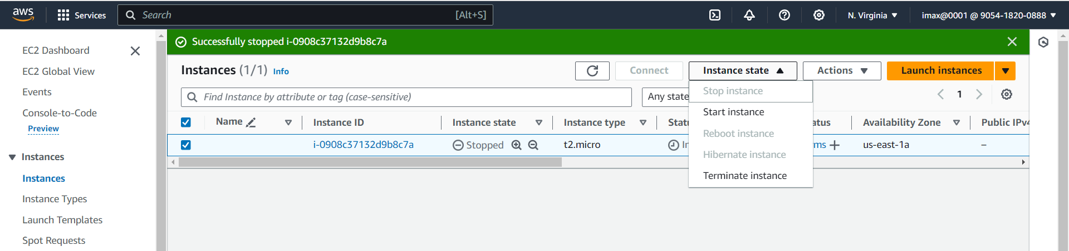

1. Now public Ip is get change( public Ip “54.87.40.232”)

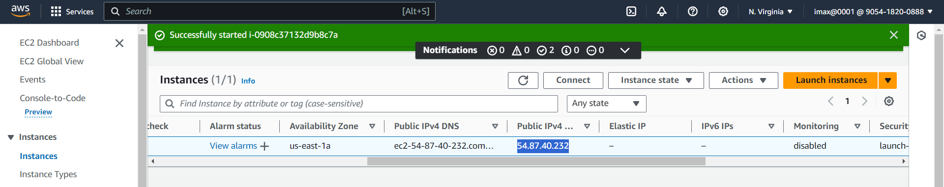

1. Hit that public Ip on web browser (Welcome to nginx!)

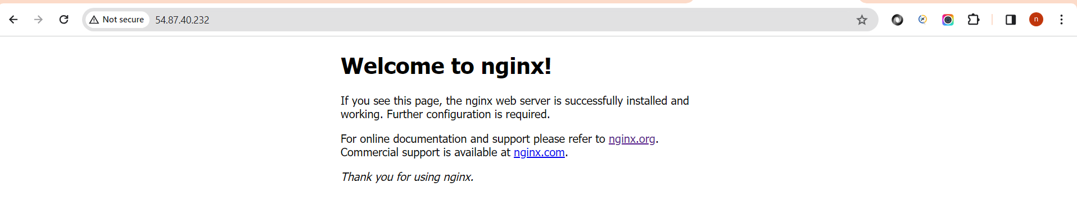

1. Go to Instance page and terminate the Instance

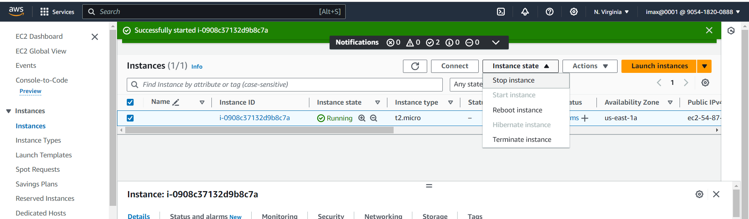

Click on terminate

